
FACULTY OF ENGINEERING
DEGREE ENGINEERING
DEPARTMENT OF COMPUTER ENGINEERING
SOFTWARE ENGINEERING (BE103505)

Unit-5 –Software Design

Design Concepts and Principles

1. Data Design
- Organizes how data is stored and managed.
- Converts analysis data into database tables and data structures.
- Defines relationships between data (e.g., Book, Student, Issue).

2. Architectural Design
- Shows the overall structure of the software.
- Defines how different modules work together.
- Example: Login, Book Management, Student Management, Reports.

3. Interface Design
- Defines how users and system modules communicate.
- Creates simple and user-friendly screens.
- Handles data flow between users, software, and database.

4. Component-Level Design
- Describes the working of each module.
- Explains the functions and logic of every component.
- Example: Book Issue module, Return module, Search module.

Design Principles
- Avoid tunnel vision – Think of different solutions before choosing one.
- Follow the analysis – The design should match the system requirements.
- Reuse existing ideas – Don't create something new if a good solution already exists.
- Keep it close to real life – The design should reflect real-world library operations.
- Be consistent – Use the same style and structure throughout the system.
- Allow future changes – The design should be easy to update.
- Handle errors properly – The system should work safely even if errors occur.
- Design is different from coding – Plan the system before writing code.
- Check quality regularly – Review the design while creating it.
- Review to remove mistakes – Check the design carefully to avoid errors before development.

Software Architecture and Software Design

Software Architecture
- Software architecture is the overall structure of a software system.
- It shows how different modules and components are organized.
- It defines how the components communicate and work together.
- It helps developers, designers, and users understand the system.
- Good architecture makes the system easier to develop, maintain, and improve.

Architectural Styles
An architectural style is a common way of organizing software.
It includes:

1. Components
- The main parts of the system that perform specific tasks.
- Example: Database, Login Module, Book Management Module.

2. Connectors
- They allow communication between components.
- Example: APIs, database connections, function calls.

3. Constraints
- Rules for how components should work together.
- They ensure the system is organized correctly.

4. Semantic Model
- Explains how all components work together as one complete system.
- Helps developers understand the system design.

Data-Centered Architecture Style
- A central database is the main part of the system.
- All modules access the same database to store and retrieve data.
- Components can add, update, delete, and view data.
- The database stores all important information.
- Example: In a Library Management System, the Book, Student, and Issue modules all use the same database.

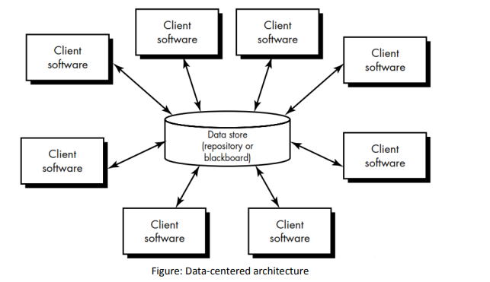

Data-Flow Architecture (Easy Words)
- Data-flow architecture is used when input data is processed step by step to produce output.
- The system passes data through a series of processing components.
- It follows the Pipe and Filter pattern.

Pipe and Filter Pattern
- Filters: Components that process data.
- Pipes: Connections that transfer data from one filter to the next.
- Each filter works independently.
- A filter receives input, processes it, and sends the output to the next filter.
- A filter does not need to know how other filters work.

Example
Input Data → Filter 1 → Filter 2 → Filter 3 → Output Data
For example, in a Library Management System:
Book Request → Check Availability → Verify Student → Issue Book → Confirmation
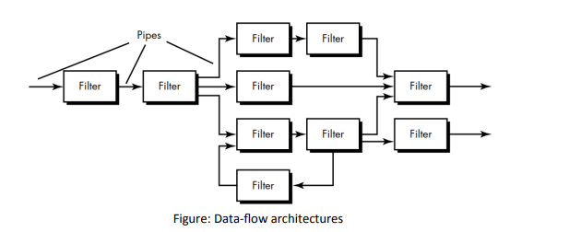

Call and Return Architecture
- This architecture divides the program into small functions (modules).
- A main program calls other functions to perform tasks.
- It makes the software easy to understand, modify, and expand.

Types

1. Main Program / Subprogram Architecture
- One main program controls the system.
- It calls different functions (subprograms) to complete tasks.
- Example: Main Menu → Login → Book Management → Reports

2. Remote Procedure Call (RPC) Architecture
- Functions are placed on different computers connected through a network.
- One computer requests another computer to perform a task.

Object-Oriented Architecture
- The system is built using objects (classes).
- Each object contains data and functions together.
- Objects communicate by sending messages to each other.
- This makes the system organized, reusable, and easy to maintain.
Example: Book, Student, and Librarian are separate objects in a Library Management System.

Layered Architecture
- The system is divided into different layers.
- Each layer performs a specific job.
- Every layer communicates with the layer above or below it.

Layers
- Presentation Layer – User interface (screens and forms).
- Application Layer – Business logic and system functions.
- Data Layer – Stores and retrieves data from the database.
- System Layer – Communicates with the operating system and hardware.
Example:
User → User Interface → Application Logic → Database → Response
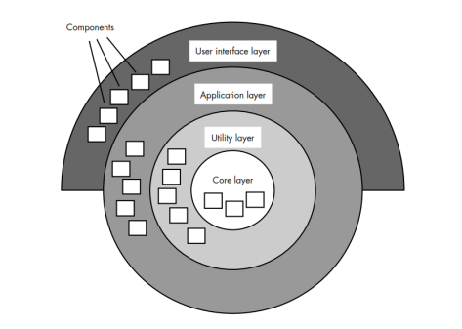

Data Design
Data design is the process of organizing and storing data so that the software can use it efficiently.

Data Design at the Architectural Level
- Focuses on the overall structure of data in the system.
- Creates a high-level model of how data is stored and used.
- Helps organize data from different parts of the system.

Data Mining
- Data mining means finding useful information from large databases.
- It helps businesses analyze data and make better decisions.

Data Warehouse
- A Data Warehouse is a central storage place for all business data.
- It collects data from different databases.
- It is mainly used for reporting and analysis.

Data Design at the Component Level
- Focuses on the data used by each module (component).
- Defines data structures needed for each function.
- Creates relationships between different data objects.
- Ensures data is organized properly.

Principles of Data Design
- Analyze data carefully before designing it.
- Identify all data structures and their operations.
- Use a data dictionary to describe all data.
- Make detailed data decisions later in the design process.
- Allow only required modules to access the data.
- Reuse existing data structures whenever possible.
- Use programming languages that support good data structures.

Component-Level Design (Procedural Design)
- Component-level design is done after data, architecture, and interface design.
- It defines how each module will work.
- It specifies the data structures, algorithms, and interfaces used by each component.
- It converts the design into working software (code).
- Each component is independent, reusable, and easy to replace.

Example
In a Library Management System:
- Login Module – Checks username and password.
- Book Module – Adds, updates, and deletes books.
- Issue Module – Issues and returns books.
- Report Module – Generates library reports.

Cohesion
- Cohesion means how closely related the tasks inside one module are.
- A module with high cohesion does one specific job only.
- It needs very little help from other modules.
- High cohesion is good because the module is easy to understand, test, and maintain.

Classification of Cohesion (Worst to Best)
- Coincidental Cohesion (Worst)
  - Unrelated tasks are kept in the same module.
  - Example: A module that prints reports, calculates salary, and sends emails.
- Logical Cohesion
  - Similar types of tasks are grouped together.
  - Example: One input module that handles keyboard, mouse, and file input.
- Temporal Cohesion
  - Tasks are grouped because they happen at the same time.
  - Example: Initialization tasks performed when the program starts.
- Procedural Cohesion
  - Tasks are grouped because they follow the same sequence.
  - Example: Read data → Process data → Display result.
- Communicational Cohesion
  - Tasks work on the same data.
  - Example: Read employee data and calculate employee salary.
- Sequential Cohesion
  - Output of one task becomes the input of the next task.
  - Example: Read file → Sort data → Generate report.
- Functional Cohesion (Best)
  - The module performs only one specific function.
  - Example: A module that only calculates the total bill.

Coupling
- Coupling means how much one module depends on another module.
- Low coupling is good because modules can work independently.
- High coupling is bad because changes in one module may affect others.

Classification of Coupling (Worst to Best)
- Content Coupling (Worst)
  - One module directly uses or changes another module's internal data.
  - Example: Module A changes variables inside Module B.
- Common Coupling
  - Multiple modules share the same global data.
  - Example: Many modules use the same global variable.
- Control Coupling
  - One module controls another by sending control information.
  - Example: A flag value tells another module which action to perform.
- Stamp Coupling
  - Modules pass a complete data structure even though only part of it is needed.
  - Example: Passing the whole student record when only the student's name is required.
- Data Coupling (Best)
  - Modules communicate only by passing the required data.
  - Example: Passing only two numbers to a function that adds them.

User Interface (UI) Design

Definition
- User Interface (UI) Design is the process of creating a simple and easy way for users to interact with a computer or software.
- It helps users communicate with the system effectively.

Design Rules for User Interface

1. Place the User in Control
Meaning: The user should feel in control of the software.
Points:
- Don't force unnecessary actions.
- Provide different ways to interact (keyboard, mouse, touch, voice).
- Allow Undo and Cancel.
- Support shortcuts for experienced users.
- Hide technical details.
- Allow direct interaction with screen objects.

2. Reduce the User's Memory Load
Meaning: The user should not have to remember too much.
Points:
- Keep screens simple.
- Use meaningful default values.
- Provide easy shortcuts.
- Use familiar icons and layouts.
- Show information step by step.

3. Make the Interface Consistent
Meaning: The interface should look and work the same everywhere.
Points:
- Show the user's current location/task.
- Keep the same design across all screens.
- Follow common interface standards.

User Interface Design Models

1. User Profile Model
Meaning: Describes the users of the system.
Types:
- Novice User – Beginner.
- Intermittent User – Uses the system sometimes.
- Frequent User – Expert or regular user.

2. Design Model
Meaning: Created by the software designer based on user requirements.

3. Implementation Model
Meaning: The actual interface (screens, buttons, help files) built by developers.

4. User's Mental Model
Meaning: The user's understanding of how the software works after using it.

Web Application (WebApp) Design

Definition
- Web Application Design is the process of designing a website or web application.
- It includes the look, layout, structure, content, functions, and navigation of the WebApp.

WebApp Design Quality Requirement

Definition
- A good design helps create a high-quality Web Application.
- It should be easy to use, reliable, attractive, and efficient.
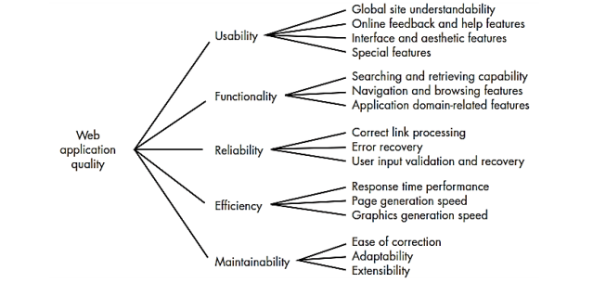

WebApp Interface Design

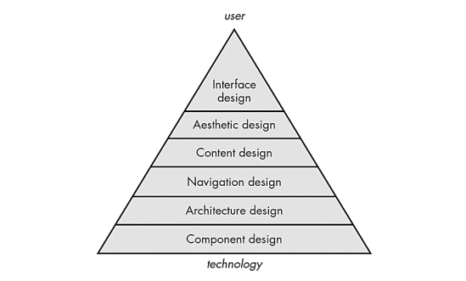

Aesthetic Design
- Also called Graphic Design.
- Focuses on the look and feel of a WebApp.
- Makes the WebApp attractive and user-friendly.
- Improves user experience.

Content Design
- Focuses on creating and organizing WebApp content.
- Includes text, images, and other information.
- Defines relationships between content objects.
- Content is created by writers and designers.

Architecture Design
- Defines the overall structure of a WebApp.
- Depends on goals, content, users, and navigation.
- Organizes pages and components.
- Helps in effective navigation.

Navigation Design
- Defines how users move through a WebApp.
- Creates links between pages and components.
- Helps users find information easily.
- Provides simple and clear navigation paths.

